roid

217, Sheikh Rashid Building

P.O Box 56272, Dubai

United Arab Emirates

Tel: +971 4 2973236

Email: uae@verbat.com

TECHNICAL   
PROPOSAL

**SURVEY MANAGEMENT SYSTEM**

|  |  |
| --- | --- |
| **Prepared for:**  **POM HOLDING LLC** | **Submission Date:**  22 February 2018  **Proposal ID:** AD/BP/01022018/1390/2 |

________________________________________________________________________________________________________________________________  
Conﬁdentiality Notice: This Proposal is conﬁdential and contains proprietary information and intellectual property of Verbanet Technologies LLC. Neither this proposal nor any of the information contained herein may be reproduced or disclosed under any circumstances without the express written permission of Verbanet.

© 2018 by Verbanet Technologies LLC. All rights reserved. Confidential.

___________________________________________________________________________________________________________________________________________

Project Contacts

|  |  |
| --- | --- |
| Client Information | |
| Project Name | Survey Management System |
| Client Name | POM Holding LLC |
| Contact Person | Suhayeb Jaabo |
| Contact Person Email | [suhayeb.jaabo@pom.ae](mailto:suhayeb.jaabo@pom.ae) |
| Contact Person Phone Number | +971 55 5424321 |
| Verbat Information | |
| Contact Person | Joyce Daniel |
| Contact Person Phone Number | +971 4 2973236 Ext 102 |
| Contact Person E-Mail | [joyce.daniel@verbat.com](mailto:joyce.daniel@verbat.com) |
| Address | PO Box 56272, Dubai, United Arab Emirates |
| Physical Address | 217, Sheikh Rasheed Building, Hor Al Anz East |
| Project Information | |
| Proposed Technology/Methodology | Entity Framework, ASP.net, MSSQL, IIS, MVC |
| Anticipate Start Date | NA |
| Proposal Valid For | 30 Calendar days from the submission of the proposal |

**Table of Content**

1 Scope of Work 5

1.1 Proposed Solution Model 6

1.2 Solution Objective 6

1.2.1 Organization Brief 6

1.2.2 Brand Asset Management 6

1.2.3 Policy Management 7

1.2.4 Survey Management 7

1.3 Advantages of Proposed Solution 8

1.4 Why Verbat 9

1.5 Key Differentiators 10

1.6 Technology & Services 11

2 Functional Specification 12

3 Entire Application Functional Architecture 14

3.1 System Level Features 15

4 High Level Solution 16

4.1 High Level Architecture 16

5 Nonfunctional Requirement (Others) 17

6 Assumptions 17

7 Out of Scope 18

8 Technology Solution 20

8.1 Proposed System Environment 20

8.2 Technical Configurations 21

8.2.1 Development Tools 21

8.2.2 Recommended Web Hosting Package 21

8.2.3 Browser Compatibility 21

8.2.4 Hardware Interface 21

9 Delivery Management 22

9.1 Project Management 22

9.2 Roles and Responsibilities 22

9.3 Delivery Activity Summary 23

9.4 Project Implementation Plan 23

9.5 Deliverables 24

9.6 Estimated Delivery Time 24

9.7 Deployment Details (at Clients Behest) 25

9.8 Release Planning 25

9.9 Risk and Contingency Planning 26

10 Change Management 27

11 Miscellaneous 29

11.1 Acceptance Criteria 29

11.2 Warranty 29

11.3 General Terms and Conditions 30

11.4 Assumptions and Dependencies 31

11.5 Source Code & Intellectual Property Rights 32

11.6 Maintenance & Support 33

11.7 Service Level Agreement 34

12 Our Clients 35

# Scope of Work

**POM Holding LLC** (hereafter referred to as “Client”) has approached **Verbanet Technologies LLC.,** trading as Verbat Technologies (hereafter referred as” Verbat”) to develop a Survey Management System.

The main components of the Survey Management System are

* Survey – A survey consists of multiple questions that revolves around a central theme. Its purpose is to elicit responses from participants to infer meaning, opinion, experience, purpose etc.
* Sections - Sections are a group of related questions
* Questions - Predefined question with a weight and list of answers. Answers options could have different formats (Lists/options, Dates, Text, Number…etc.)
* Group / Department - The survey will be executed against individual/department/vendor to collect, measure and evaluate performance of the individuals.

Once the survey is designed, the manager selects the target audience to whom it will be administered. The system shall grade the answers provided by the users. Based on this different types of analytical reports shall be generated to aid in further analysis

Stated below are the functional Requirements of the survey application

* Categorize the Survey based on the business unit/ departments.
* Categorize the Survey based on the Activity Type.
* Survey can be generated based on both Sites and Projects.
* Build a standard rating system for all surveys.
* Communicate the Survey result and score with any 3rd party through emails.
* To provide ad-hoc reporting system based on the survey results:
  + Management reporting (dashboard)
  + End User (Printable and Downloadable excel and PDF format)
  + PDF, XLSX , DOCX. reports sent to any 3rd party through Email

Verbat is a Digital Technology Services company with over 18+ years of experience in delivering Internet and Mobile Solutions to Enterprises, through Agile Development and Application Management methodologies. Application Development is an area where Verbat has in-depth knowledge and expertise. Being the pioneers in Web based solution across the major verticals, we are sure to help customers drive differentiation. We bring proven methodologies and processes, global expertise in application development, and a legacy of best practices & ready-to-fit frameworks to expedite the development cycle in order to reduce the total cost of ownership.

Verbat is pleased to have received the request to submit the technical proposal and values it as a great opportunity to have a long term & mutually beneficial association with the client. Verbat has gone through the requirement and presents a technical proposal for the below shared requirement.

## Proposed Solution Model

**Stand-Alone Fixed Bid**

Verbat will be following a stand–alone fixed bid solution delivery model wherein the required solution would be devised and a suitable pricing would be offered.

## Solution Objective

Verbat shall develop the application to incorporate the following requirements cited by the client:

### Survey Management

Application should allow the achievement of the following functions:

* Trigger-based surveys at the right time to maximize engagement.
* Comprehensive statistics of answers
* Different answers types, text, and multiple choice, photo/video by upload or camera.
* Support nested branching to skip/add questions based on responses.

Detailed requirements will be covered in the section titled “Functional Specifications”

Verbat’ s Solution architects have conducted a thorough research on the requirements and have come to the conclusion that our proposed solution, which is detailed further in this document, will meet the requirements put forth by the client. And the proposed solution will be delivered in a phased approach as per Verbat’s stand-alone fixed bid solution model.

**Strong and Scalable platform:** The platform proposed will be strong and scalable enough to accommodate future enhancements.

**Accelerated solution:** The framework would act as a solution accelerator. It would provide the basic building blocks which could be reused in future for building new components and features.

**High performance:** The light weight framework used consumes fewer system resources thereby making the application perform faster.

**Security:** The application will be developed considering various aspects of security.

## Advantages of Proposed Solution

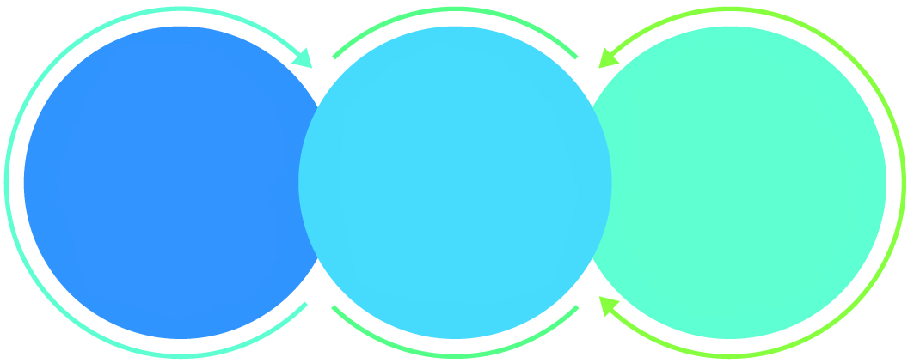

01

Agile development offering reliable, secure solution

02

Smooth transition and quicker completion of processes

03

User friendly interfaces enabling easy navigation between screens

## Why Verbat

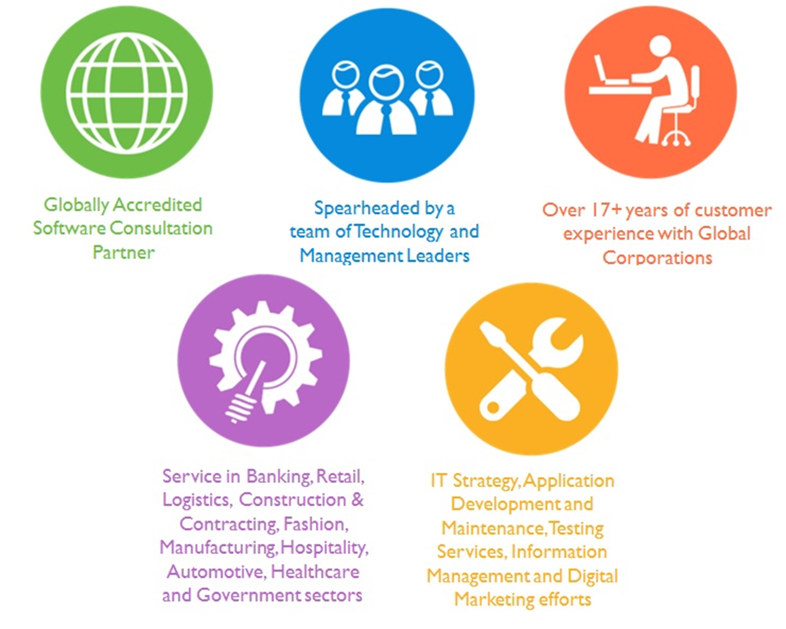

Over 18+ years of customer experience with Global   
Corporations

## Key Differentiators

Delivered digital transformation expertise to global customers for over a decade by following industry best practices to maximize ROI for client

Keen technology intelligence combined with aggressive market research to deliver solutions that achieve results with measurable value

Enable access to global consulting expertise with strong local market and business knowledge

Commercial Model that is customizable for your business needs

Services that are designed to optimize applications for improved performance and overall efficiency

1,000,000 plus man-hours of expertise in technology frameworks spanning Microsoft, Open Source, mobility platforms and other proprietary IT technology

Partners top technology vendors to bring in the latest and best services in integration, collaboration, and development

Commercial Model that is customizable for your business needs

Proven Methodologies & Processes

Investment in R & D

Strong Local Presence

Flexible commercial Models

Technology Associations

Software Development Experience

Offshore Development Centre

Quality Assurance & Testing

## Technology & Services

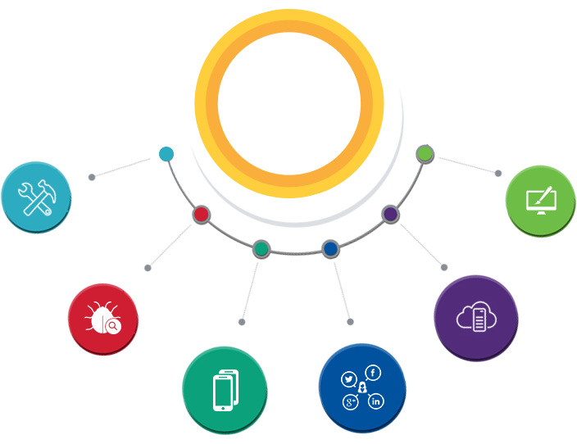

Technology  
&  
Services

Cloud/Traditional Hosting

User Interface & Design

Digital Marketing

Mobility Solutions

Testing Services

Application  
Development

# Functional Specification

|  |
| --- |
| **Option 2** |
| **Survey Management (Web Based)** |
| Categorize survey (Dept., Business Unit, Svc Type) |
| Survey definition |
| Standard rating system for surveys |
| Survey workflow |
| Survey based reports with reporting dashboard |
| Export functionality (PDF, XLS, DOC) |
| Create survey questions |
| Create Dynamic controls for survey |
| Text, Date, Dropdown , Options, Radio buttons, Check boxes |
| Survey Scheduling |
| Generate Survey |
| Upload documents with document management features |
| Email surveys |
| Survey Master Data |
| Site code, building code, Floor code |
| Room code, equipment standard, Equipment code |
| Project code, Vendor code, status, Dept., Svc Type |
| **System Features** |
| Advanced document search (by name, subject, category, meta tags, date etc.) |
| Authentication & authorization |
| Auditing & logging |
| Exception handling |
| Manage files and folders |
| Generate thumbnail for videos and images |
| User management (create, update, delete) |
| Add New user attributes |
| Create User roles (CxO's, Gate pass, Survey & Asset managers, admins etc.) |
| Entitlements |
| Manage meeting locations |
| Manage Departments |
| Manage Projects |
| Manage Performance Goals |
| Document and asset management framework |
| meta tag management |
| Survey question management |

*Note: The above features and functionalities are based on our initial understanding of the requirement. Features and functionalities may change after detailed system study /* meeting

# High-level Overview

## Process Flow

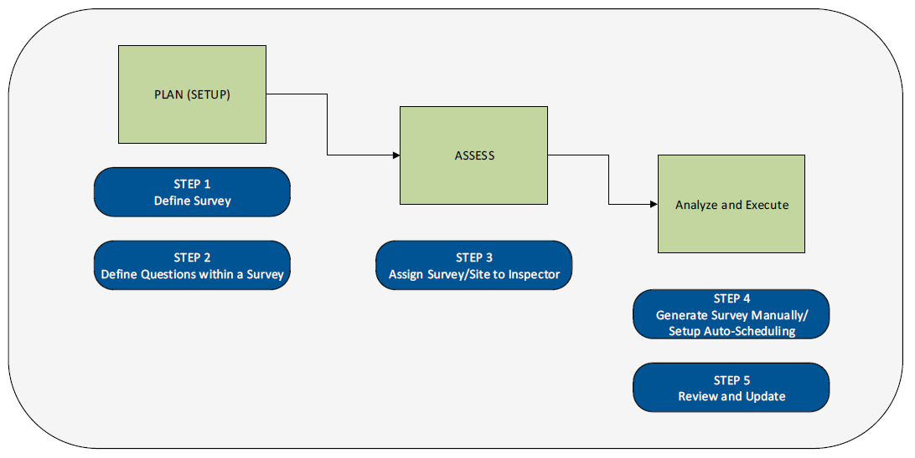

## Workflow

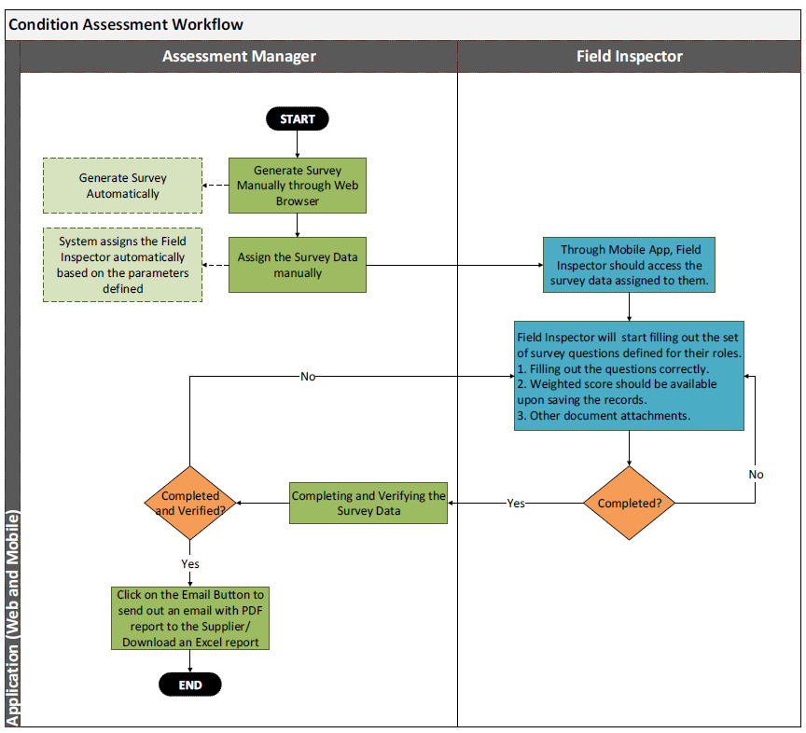

.

Survey Management as per the “Functional Specifications “

## System Level Features

* Authentication and Authorization
* Auditing and Logging
* Scheduled Jobs:
* Workflow Management:
* Exception Handling:
* Document Archival
* Security

# High Level Solution

## High Level Architecture

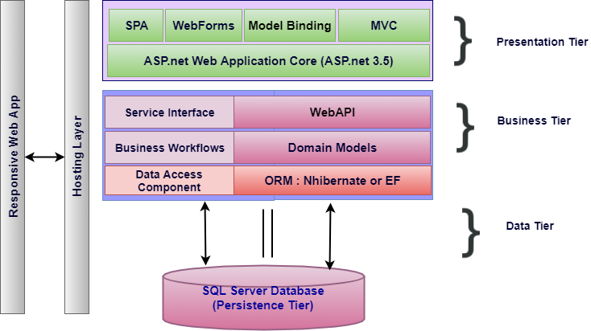

Figure 1 High Level Technical Architecture

The proposed architecture combines the classic MVC architecture along with elements drawn from Service Oriented Architecture (SOA). SOA compliments the requirement where the client’s needs to extend the functionality of the application by retrofitting add-on services in the future.

The business layer represented in the figure above is a service layer that is modelled by the business domain. Hence it becomes easy to contain and isolate workflows. Each service layer results from the culmination of a broad range of granular micro services that work in concert to deliver the desired functionality. If there is a future need for adding new services, this can easily be accommodated by building a parallel pipeline.

MSSQL is preferred relational database, as per the client. For Rapid Application Development (RAD), most application frameworks employ Object Relational Mappers (ORM). .Net supports both nHibernate as well as Entity framework, both of which are

# Nonfunctional Requirement (Others)

|  |  |
| --- | --- |
| **Requirement** | **Details** |
| User Experience and  UI Design | * The application will be developed only in English * The layout and graphical components will be created considering the usability factors |
| Performance | * Application will allow users to have smooth and quick access to the information or services they require. |
| Security | * Web security standards will be followed. |

# Assumptions

The project solution and technology is created from the initial understanding of the requirement shared with Verbat through mails and meetings. The proposed solution is based on the following assumptions:

1. **Objective:**
   * The requirement is to develop an internal portal with the functionalities as defined in the “Functional Requirements” section
2. **Design:**
   * Client to provide Verbat with the branding guidelines.
   * Color theme shall be provided by the client
   * The proposed application front end and backend would be in English
   * Verbat is free to use custom made template for design, if required.
   * Client shall provide licensed images and logos in specified size & format
3. **Development:**
   * Super Admin can manage all the users within the application.
   * The client will finalize the functional requirements and Prototype before the commencement of the development of the project
   * Requirements should be well defined, agreed and signed-off by the client before the project initiation
   * Internet connectivity is required for the functioning of the web application.
   * Reporting and analytics may require external tools. Current assumption is that analytics will be minimal and simple.
   * Testing will be done in latest versions of Google Chrome, Mozilla Firefox & Edge only
   * Development Contingent upon timely feedback from client
   * Access to LDAP, Active Directory etc. to be provided by the client
   * Application Installation, if contracted, will be done remotely using RDP
   * Verbat will advise the client on server hardware requirements after assessing the potential load on the server based on client base, data requirements, etc.

# Out of Scope

With the ever evolving digital market, the requirement needs should be clear to both the parties involved, hence the importance of mentioning the out of scope details of the project. Following are considered to be out of scope while creating this proposal.

* + Purchase of images, fonts, domain names
  + Content or image procurement or uploading or editing.
  + Content writing / proof reading
  + Any language other than English
  + Integration with third-party, if any, other than mentioned in the functional specifications
  + Mobile App Development / Responsive
  + Audit Trail
  + Adding new features to the application other than mentioned in this proposal. Such requests will be handled via change management. For Change management details, please refer section titled “Change Management” in the Proposal.
  + Annual Maintenance of the application (Bug fixing, debugging) - For AMC details, please refer section titled “Maintenance and Support”
  + Manual data entry
  + Migration of existing data / Database migration
  + Data Replication
  + Hosting Infrastructure and Maintenance (web and email hosting)
  + Application Deployment / Physical deployment onsite / installation of the application in devices and Physical connection, installation of system
  + Data backups and disaster recovery

# Technology Solution

## Proposed System Environment

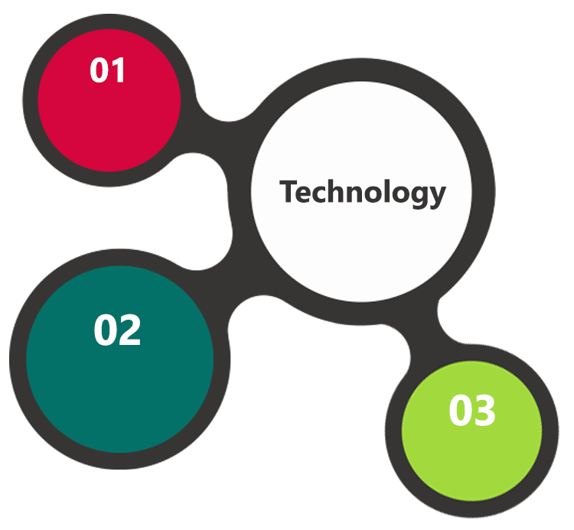

HTML / CSS3 /

JQuery

IIS..Net 4.5  
MSSQL

Angular/C#

**MS SQL2012  
Windows 8/10  
Web Services**

## Technical Configurations

### Development Tools

* Visual Studio, MVC, c#, Angular
* MSSQL
* HTML / CSS 3
* Ajax, JavaScript, JQuery

### Recommended Web Hosting Package

* CPU: 4 cores
* RAM: 12 GB
* Disk Space: 200 GB
* Data Transfer: 200 GB
* OS Windows server 2012
* Database: MSSQL
* Web site Server Software – IIS 8.0

### Browser Compatibility

* Chrome version: 56
* Firefox version: 51
* Edge version: 39

### Hardware Interface

The application is reliant on hardware interfaces to provide a seamless automated user experience.

* Computer with Windows 8 or 10 OS
* Compatible Browsers as specified in section 8.2.3

# Delivery Management

## Project Management

The Verbat development center strictly follows industry standards on quality. The project management is process governed by the Verbat Quality Management system and is put to verification through internal audit programs that happen from time to time.

Verbat will dedicate a project manager for the proposed implementation. Verbat proposes Client to identify one project manager who will be driving activities to be undertaken by Client to be the single point of contact for Verbat.

## Roles and Responsibilities

Verbat will assign a dedicated Project Manager/Project Lead to lead the project, who will be the first point contact for Client. He/she will be responsible for planning and managing the various activities within the project. He/she will work closely with Client Project Manager, to give periodic status updates and ensure high level of visibility and comfort on the progress of the project.

The Project Manager/Project Lead will lead the co-ordination between Verbat and Client, thus enabling smooth transitioning of Client requirements to the Verbat’s offshore delivery team, and provide visibility as well as comfort on the progress of the services to Client.

He/she will have periodic meetings with Verbat’s Senior Management, thus ensuring Verbat’s Management commitment and focus on Client initiatives.

## Delivery Activity Summary

|  |  |
| --- | --- |
| Activities | Description |
| Detailed requirement Analysis | Verbat team to conduct detailed study of requirement for the phase. If clarification is required, team will reach out to Client for more information and/or time for discussions. |
| DB Design | DB design for central and test DB. |
| Software Requirement Specification document (SRS) | Once the requirement analysis is completed, Verbat team will submit the SRS document for approval |
| UI/UX Design, Prototyping | Based on the SRS, Verbat UX/UI team will work on the UI/UX of the screens and submit a prototype for approval |
| Functional Specification Document (FS) | Once the Prototype. UI/UX is approved, Verbat shall submit an FS document for approval. |
| Development | Actual system development starts based on the FS. This involves detailed design and software development of Web Application. |
| Testing | Test Planning, test plan creations, internal, integration testing and user acceptance testing. |
| Deployment | Deploying the latest built in the Verbat Test Server. |

## Project Implementation Plan

Verbat will be providing the solution in a stand-alone fixed bid approach which ensures minimum viable solution for quick wins with core focus on the long-term business objective and outcome. Once the implementation is over, Verbat will initiate the application maintenance process (once the maintenance contract is signed) which continues to extend after the implementation.

## Deliverables

* Project Plan
* Software Requirement Specification Document (SRS)
* Prototype
* Functional Specification
* Fully Developed & Tested Application
* Source Code

## Estimated Delivery Time

| **Activity** |
| --- |
| Contract Signoff (T0) |
| Project Initiation & Initiating requirement gathering |
| Software Requirement Specification Document(SRS) |
| SRS Approval (T1) |
| System Prototype-Complete |
| System Prototype-Approval (T2) |
| Functional Specification (FS) |
| FS Approval (T3) |
| Development Phase-Complete |
| Perform QC (Unit Testing and Integration Testing) |
| System ready for UAT |
| UAT Acceptance on Verbat server (T4) |

*Note:*

* *The above-mentioned timeline is in UAE Working Days*
* *The initiation of the prototype development is dependent on the confirmation of SRS. SRS will be submitted post the confirmation of the project along with LPO, signed proposal and advance payment.*
* *SRS will be submitted after the project initiation and detailed system & supersedes any document previously signed by the customer with regard to features & functionalities.*
* *The above mentioned timeline for development is post the confirmation of FS*
* *Project plan will be submitted post the confirmation of project with necessary payments*
* *Any delay in getting the approvals of deliverables from client will cause change in timelines and the revised timelines will be updated in weekly status reports shared with client after the project commencement*
* *All approvals and queries regarding the client requirement and any queries which may hinder the project advancement at any stage should be answered by the client within 24 hours from the time of initiation, failing which the time delay will get added to the actual effort and timeline which was estimated.*

## Deployment Details (at Clients Behest)

* If deployment is at the client’s server, responsibility of deploying the application onto the production environment after conducting the necessary acceptance testing will lie with the client unless and until Verbat’s support is contracted for deployment.

***Note****: Hosting the application at Verbat’s server will incur additional charges.*

## Release Planning

* Client will be informed about the release date and time through email.
* Client performs the UAT

## Risk and Contingency Planning

Verbat has identified various risk factors associated with this assignment and understands the impact of these risk factors on the project schedules. The objective of this section is to highlight for both Verbat and client, the risk factors, to analyze the impact of the risks on project execution, and to propose strategies to control and reduce the impact of the risk factor.

These various risks, which could arise during the project, are tabulated below along with mitigation implementation.

| Type of risk | Impact | Risk Mitigation | Risk Handling |
| --- | --- | --- | --- |
| Scope Creep | H | Functions and features will be detailed in system requirement documents and will go through client approval. Once this document is approved, any change to requirement will go through change management review for possible impact assessment. | Proper change management procedure will be implemented. |
| Delay in customer feedback | H | The plan is prepared with enough lead-time for customer reviews and approvals.  The customer is indicated with the dates when the document is expected after review and approval. | The request for feedback will be escalated if not attended at the right time so that the schedules are not affected. Deemed acceptance criterion is set up front and will be followed. |
| Non-availability of necessary software’s, frameworks, database instances and infrastructure at client’s hosting environment(If hosting support is provided by Verbat) | M | Client will be informed in advance on these requirements. | Possible impact to schedule. |
| Manpower attrition | L | All efforts would be made to ensure process dependence rather than being person dependent. As a risk mitigation plan Verbat will train backups. | A new person will be identified as early as possible, provided the required project-specific training and mentored by the senior members of the team to minimise impact of attrition on the project. |

*H-High, M-Medium, L-Low, NA-Not Applicable*

# Change Management

Any addition which comes out of the project scope, upon and after the launch of the tool will be considered as change management. Verbat recommends the following change management procedure for the same.

* Any change which comes out of the project scope, which was discussed, documented, and mutually approved by both the parties in the requirement stage, will be carried out only through raising a change request.
* Change request will be studied and an impact analysis on the existing work flow will be performed.
* On finalizing the impact, effort estimation for the change will be calculated and raised as additional requirement.
* Verbat will initiate the change request only after getting a formal approval from the client for the additional changes raised.
* Any change from the scope will be charged at **AED 1,200.00 per man day effort** and approval from the clients will be availed before commencing on any change management.

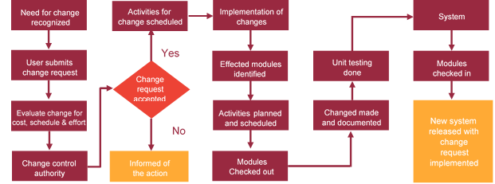

# Miscellaneous

## Acceptance Criteria

* UAT sign off should happen within 14 Days from the first release of the application/

Phase and the acceptance confirmation needs to be mailed to Verbat failing which

Verbat will consider the project as approved by the client.

* Any comments or reason for rejection need to be documented and the same needs

to be sent as an email from the official mail id of client to Verbat on or before 14 days

from the first release.

* Timeframe for acceptance for any further release will be mutually agreed and finalized

between client and Verbat depending on the UAT Comments

## Warranty

* Verbat shall provide a bug ﬁx warranty at no additional cost for 30 days from the date of acceptance of the project, for correction of any errors in the developed application that may be attributed to Verbat.
* However, this does not cover modifications by Client, or use of the application on an environment other than the proposed environment, or other circumstances outside Verbat’s reasonable control. In such a case Verbat reserves the right to charge for its services.
* All error corrections will be executed at Verbat India office. In the event of any need for on-site work, all expenses incurred for such trips will be payable to Verbat by Client.

## General Terms and Conditions

* Offer Valid for 30 calendar days from the date of submission of the Proposal.
* An average of 20 working days are assumed in a month
* All the projects activities will be carried out from our off-shore development center in India
* All the documentation will be provided in English.
* Third party components may be used to develop this application.
* The scope of the project is to develop the Application as detailed in the scope of the project and mentioned in this proposal. Any changes or additions will have to go through change management.
* This proposal and all technical/ functional specifications have been derived or concluded from the data shared via email. Verbat reserves the right to amend the terms of this proposal, should the SOW terms, functional features and functionalities change during the course of the project
* Web Application will be best viewed only in the environment mentioned under “Browser Compatibility”
* The applications will be built as per the specifications agreed mutually. Any changes will be executed through a defined change management process between both parties.
* All Source Code and other project artefacts would adhere to the Verbat document templates and internal coding standards
* Acceptance criteria shall be based on the clauses which were mutually discussed between Verbat and client at the Requirement Analysis phase and the same will be documented and approved by both parties through official emails
* In case Client requires any extension of the proposed acceptance schedule, the associated effort and cost of such extension can be mutually reviewed.
* For any circumstances if project needs to be put on Hold / Stop it requires minimum request notice period of 1 week along with duration for which request will be addressed by management and final decision on the request will be based on that
* If deployment is done in client’s server, Verbat cannot be held responsible for any performance issues arising due to hardware malfunctions.
* Client is responsible for data backup in case the application is not hosted on Verbat server.
* Source code will only be delivered or uploaded on the Production Server once the due payments are made.

## Assumptions and Dependencies

* Detailed system study is required before the start of the project.
* During the requirement gathering phase, authorized personnel from the Client’s side is expected to be available for discussion and finalizing the HLD (High Level Design), before development commences.
* Type of reports and formats, if under the scope of the project, needs to be specified by Client before project sign off.
* Workflows if under the scope of the project, need to be specified/ confirmed by client before project signoff.
* All queries regarding the client requirement and any queries which may hinder the project advancement at any stage should be answered by the client within 24 hours from the time of initiation, failing which the time delay will get added to the actual effort which was estimated.
* Verbat assumes that all sign-offs from Client will be provided within agreed and specified timeframe.
* Client will provide all the necessary contents, both text and image, before starting the project in the format suggested by Verbat (if any).
* The client should provide the relevant information and data well in time for the execution of a related activity. Non- availability of this information or data may lead to an interruption of work which may result in a delay in delivery as well as additional costs to the client.
* Client should have/possess server with technical specifications as suggested by Verbat for the proposed application.
* Client will be provided with one time training on how to use the application (maximum of 4 hours, maximum of 4 attendees). Additional training requests will be charged

## Source Code & Intellectual Property Rights

* Upon completion of the Project and 100% completion of the payment, client will have access to the source code except for propriety codes, developer tools and third party application etc.
* The solution offered will be the intellectual property of the client and will be made available to the client on an “unlimited license” basis.
* Modifications by third party/person: No person or organization, other than Verbat or any person authorized by Verbat in writing, has any permission to modify/change the software Solution to be eligible to get continued support from Verbat as per the support terms defined under this document.
* Liabilities/Damages: Verbat accepts no liability or damages of any kind arising out of use or non-use of the software delivered. The responsibility of testing of software lies with Client.

## Maintenance & Support

* Maintenance contracts by default are supported as per the basic SLA terms.
* **AMC with Basic SLA is charged at 20 % of the total project value**. Additional Effort/change management request will be added towards Total Value of the Project to determine the AMC value.
* Maintenance support is limited to providing application support for ensuring the consistency of the look-and-feel, bug fixes and user issues i.e. maintenance and support of the existing features of the application.
* Support does not in any way cover providing technical or other support to the end users. The maintenance agreement does not include functionality changes or feature additions which are handled as change requests which will be charged AED 1,200.00 per man day. AMC does not include server support, maintenance and application deployment.
* AMC charges will cover Off-Site Support and Debugging. Support includes E-mail, Telephone and Chat unless explicitly specified. In the event, the application is hosted with the client; necessary remote desktop connectivity should be provided for carrying out maintenance activity.
* Gap in AMC - In case if the client does not opt an AMC for a year and want to renew it after that period, 50% of the AMC amount for the year for which AMC is not taken will also be payable if the client wishes to renew the AMC contract.
* Note:
  + Please note that the AMC support shall start only after all the necessary sign-offs (AMC Document) to this effect have been given.
  + It is not mandatory that the client should opt for an AMC. The client will still be supported on an ad-hoc basis on an agreed man-day rate.
  + AMC Payment Terms: 100% to be paid as advance.

## Service Level Agreement

|  |  |  |  |  |
| --- | --- | --- | --- | --- |
| **Key** | **Max Response Time** | | **Max Resolution Time** | **Target** |
| Basic | 1  working day | 3 working days | | Request / incident / problem tickets |
| Advanced | 5 Business Hours | 12 Business Hours | | Request / incident / problem tickets |
| Priority | 3 Business Hours | 5 Business Hours | | Request / incident / problem tickets |

Note:-

* We provide Basic SLA as standard with AMC while Advanced and Priority SLAs attract additional charges.
* Time zone applicable as per India time zones (3:30 AM GMT to 12:30 PM GMT- Monday to Friday).

AMC Option:

* Client can opt for time and material based Annual Maintenance, the details of which will be shared post the completion of project.

# Our Clients

**UAE University**

Education

Transportation

**Canada Cartage**

Construction

Services

Finance

We look forward to hearing from you soon and hope that you will give us the privilege to work with you in meeting your business goals. Thank you.

Thank You



©   
1999 - 2018. All Rights Reserved   
Verbanet Technologies LLC  
www.verbat.com